Report – Week 1
Project Title: Campus Graph Modeling for Autonomous Navigation
Prepared by: vemana Hemanth babu
Week: 1

1. Introduction
The first week of the project focused on building a structured representation of the campus environment for autonomous navigation and path planning. The approach adopted was to model the campus as a graph, where nodes represent landmarks and waypoints, and edges represent walkable/drivable paths between them. This representation will serve as the foundation for implementing pathfinding and coverage algorithms in subsequent weeks.

2. Methodology
- Data Collection
  - A KML file of the campus map was parsed to extract geographic coordinates.
  - Important landmarks (blocks, gates, hostels, sports facilities, and utility points) were identified as graph nodes.
- Path Segmentation
  - Polyline data from the KML file was segmented into path nodes.
  - Intermediate points along pathways were preserved to capture accurate routes.
- Graph Construction
  - Each node was assigned latitude and longitude.
  - Connections (edges) between nodes were created using the extracted paths.
  - Distances between connected nodes were calculated using the geodesic formula, ensuring accurate edge weights.

3. Node Identification
Key landmarks modeled as graph nodes include:
- Academic Infrastructure: Block A, Block B, Bridge
- Accommodation & Services: Hostel, Food Court, Rest Area
- Entry & Security Points: In Main Gate, Out Gate, Check Post, Flag Post
- Sports Facilities: Basketball Ground, Cricket Ground, Football Ground, Volleyball Ground, Tennis Court

4. Path Network (Edges)
The graph edges represent campus pathways, structured as follows:
- In–Out Path: Detailed path from Main Gate (IN) to Out Gate with ~39 intermediate nodes.
- Block A Path: Loop structure covering Block A with ~5 nodes.
- Block B Path: Internal circulation path with ~11 nodes.
- Food Court Path: Short pathway loop with ~2 nodes.
- Sports Path: Network of edges linking cricket, football, volleyball, and basketball grounds (~8 nodes).

5. Graph Model Summary
- Graph Type: Weighted, undirected
- Nodes (V): ~120 (landmarks + path points)
- Edges (E): ~150+ (path segments with distances)
- Purpose: Provides a navigable model of the campus for algorithms such as BFS, Dijkstra, and A*.

6. Week 1 Deliverables
- Extracted coordinates of all major landmarks and path points
- Constructed campus path network with distances
- Built weighted undirected graph representation
- Prepared adjacency structure for algorithmic use
- Draft report compiled for documentation

Appendex 1 :
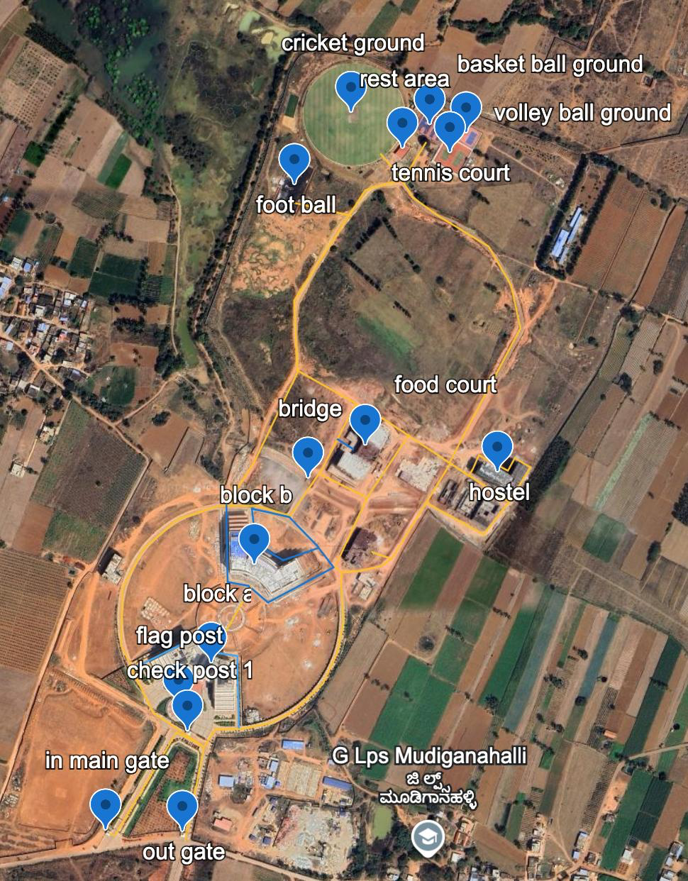

Coordinates :
name | lat | lon
basket ball ground | 13.228789 | 77.7581186
block a | 13.2221815 | 77.7553608
block b | 13.223385 | 77.7559033
bridge | 13.2244444 | 77.7565826
check post 1 | 13.2213483 | 77.7550606
cricket ground | 13.2289443 | 77.7571282
flag post | 13.2216676 | 77.7549481
food court | 13.2248484 | 77.757305
foot ball | 13.2280544 | 77.7564117
hostel | 13.2245187 | 77.7589759
in main gate | 13.220146 | 77.7540314
out gate | 13.2201213 | 77.7549963
rest area | 13.228501 | 77.7577772
tennis court | 13.2284459 | 77.7583724
volley ball ground | 13.2286875 | 77.7585775
in out path_pt0 | 13.2201484 | 77.754067
in out path_pt1 | 13.220121 | 77.7541376
in out path_pt2 | 13.2213784 | 77.7549138
in out path_pt3 | 13.2211974 | 77.7552602
in out path_pt4 | 13.2214076 | 77.7554007
in out path_pt5 | 13.2214187 | 77.7557399
in out path_pt6 | 13.2214822 | 77.7560814
in out path_pt7 | 13.2216374 | 77.7563951
in out path_pt8 | 13.221968 | 77.7567581
in out path_pt9 | 13.2223423 | 77.7569412
in out path_pt10 | 13.2227245 | 77.7570238
in out path_pt11 | 13.223194 | 77.7569927
in out path_pt12 | 13.2233263 | 77.7570011
in out path_pt13 | 13.2233432 | 77.7572192
in out path_pt14 | 13.2234056 | 77.7574959
in out path_pt15 | 13.2235012 | 77.7576368
in out path_pt16 | 13.2246702 | 77.7583733
in out path_pt17 | 13.2241933 | 77.7591179
in out path_pt18 | 13.2246216 | 77.7593838
in out path_pt19 | 13.2247356 | 77.7591882
in out path_pt20 | 13.2245795 | 77.7591005
in out path_pt21 | 13.2247285 | 77.7588102
in out path_pt22 | 13.2247711 | 77.758734
in out path_pt23 | 13.224605 | 77.758659
in out path_pt24 | 13.2245172 | 77.7586047
in out path_pt25 | 13.2246682 | 77.7583747
in out path_pt26 | 13.2252401 | 77.7574904
in out path_pt27 | 13.2253983 | 77.7571739
in out path_pt28 | 13.2246156 | 77.7567622
in out path_pt29 | 13.2240273 | 77.7563461
in out path_pt30 | 13.2241483 | 77.7559245
in out path_pt31 | 13.2241474 | 77.7554317
in out path_pt32 | 13.2239886 | 77.7549292
in out path_pt33 | 13.2236199 | 77.7544915
in out path_pt34 | 13.2231404 | 77.7542347
in out path_pt35 | 13.2224535 | 77.7542173
in out path_pt36 | 13.2219982 | 77.7544308
in out path_pt37 | 13.2216233 | 77.7546207
in out path_pt38 | 13.2211942 | 77.7552608
in out path_pt39 | 13.2200422 | 77.7550207
block a path_pt0 | 13.2221645 | 77.7543718
block a path_pt1 | 13.2225496 | 77.7551626
block a path_pt2 | 13.2223644 | 77.7553294
block a path_pt3 | 13.2223121 | 77.7556788
block a path_pt4 | 13.2214225 | 77.7556995
block b path_pt0 | 13.2241637 | 77.7555433
block b path_pt1 | 13.2232182 | 77.7555571
block b path_pt2 | 13.2231686 | 77.7558208
block b path_pt3 | 13.2229653 | 77.7560678
block b path_pt4 | 13.2233878 | 77.7568993
block b path_pt5 | 13.223632 | 77.7567077
block b path_pt6 | 13.223482 | 77.7562584
block b path_pt7 | 13.2236783 | 77.7559143
block b path_pt8 | 13.2241138 | 77.7558641
block b path_pt9 | 13.2240122 | 77.7563361
block b path_pt10 | 13.2236407 | 77.7567053
a to b connection_pt0 | 13.2231609 | 77.7558573
a to b connection_pt1 | 13.2223594 | 77.7553847
a to b connection_pt2 | 13.2223376 | 77.7553857
food court_pt0 | 13.2248403 | 77.7571544
food court_pt1 | 13.2249696 | 77.7569428
path_pt0 | 13.2233908 | 77.7569157
path_pt1 | 13.2242469 | 77.7573211
path_pt2 | 13.2245504 | 77.7567011
path_pt0_1 | 13.2242326 | 77.7573074
path_pt1_1 | 13.2250298 | 77.7578546
path_pt0_2 | 13.224184 | 77.758066
path_pt1_2 | 13.2237967 | 77.7587931
path_pt2_1 | 13.2241919 | 77.7591154
sports_pt0 | 13.2246684 | 77.7583559
sports_pt1 | 13.2263325 | 77.759259
sports_pt2 | 13.2268573 | 77.7591396
sports_pt3 | 13.2273359 | 77.7588547
sports_pt4 | 13.2277131 | 77.7582231
sports_pt5 | 13.2279426 | 77.7578966
sports_pt6 | 13.2281434 | 77.757768
sports_pt7 | 13.2286205 | 77.7580675
Untitled path_pt0 | 13.2281664 | 77.7577665
Untitled path_pt1 | 13.2284814 | 77.7574913
path_pt0_3 | 13.2281579 | 77.75775
path_pt1_3 | 13.2280328 | 77.7573003
path_pt2_2 | 13.2266746 | 77.756401
path_pt3 | 13.2257888 | 77.7564432
path_pt4 | 13.2246798 | 77.75589
path_pt5 | 13.2243175 | 77.7556502
path_pt6 | 13.2241481 | 77.7556092
path_pt0_4 | 13.2253987 | 77.757196
path_pt1_4 | 13.2258189 | 77.7564283
path_pt0_5 | 13.2277134 | 77.7571301
path_pt1_5 | 13.2278778 | 77.7563801
Untitled path_pt0_1 | 13.2233201 | 77.757006
Untitled path_pt1_1 | 13.2233882 | 77.7569141
Untitled path_pt0_2 | 13.2234999 | 77.7576098
Untitled path_pt1_2 | 13.2235801 | 77.7573776

